LAB 1

WEB ENGINEERING

MUJTABA SHAHID FAIZI

BSCS-5A

131818

TASK 1 & 2

<html>

<header>

<title> Mujtaba Shahid Faizi </title>

</header>

<body>

<h1>My Portfolio</h1>

<h2>I want to work!!</h2>

<ul>

<li><a href="#home">Home</a></li>

<li><a href="#contact">Contact</a></li>

<li></li>

<a href="file:///C:/Users/mfaizi.bscs15seecs/Downloads/gallery">Gallery</a>

<li><a href="#About">About</a></li>

</ul>

<a name="home"/>

<h2>This is a sample HTML</h2>

<p>&nbsp;</p>

<p>&nbsp;</p>

<p>&nbsp;</p>

<TABLE WIDTH=“50%" height="98" BORDER=3 ALIGN="center" CELLPADDING=“6” CELLSPACING=“2”>

<TR>

<TD colspan=3 align='center'>

<b>Lab Task B</b></font>

</TR>

<TR>

<TD width="80"><b>Name</b></TD>

<TD width="80"><b>Subject</b></TD>

<TD width="80"><b>Interest</b></TD>

</TR>

<TR>

<TD>Osama</TD>

<TD rowspan=2>Web Engineering</TD>

<TD rowspan=2> <img src="file:///C|/Users/mfaizi.bscs15seecs/Downloads/like-0.jpg" width="45" height="55" /> </TD>

</TR>

<TR>

<TD>Fatima</TD>

</TR>

</TABLE>

<h2 id="home"> Education </h2>

<p>I did my FSC in Fauji Foundation College, new lalazar, rwp. I chose pre-engineering and achieved 880 marks out of 1050 i.e. 80%. Currently, i am doing bachelors in computer science from NUST-H12. I have completed 3 semesters and have chose a liking towards android deveopment.</p>

<ul>

<li>Edit this to make your own portfolio</li>

<li>Comment everything</li>

<li>upload it on GitHub, so we can use it later on</li>

</ul>

<p>&nbsp;</p>

<p>&nbsp;</p>

<p>&nbsp;</p>

<p>&nbsp;</p>

<h2 id="About">Who am I?</h2>

<p>I am a human being</p>

<p>I live to eat, drink and play!</p>

<p>I like coding!!</p>

<p>This is a date</p>

<p>Finding your location: checking..</p>

<p>Drag the image into the rectangle</p>

<p></p>

<p></p>

<p>&nbsp;</p>

<p id="contact">Phone: 03332112211</p>

</body>

</html>

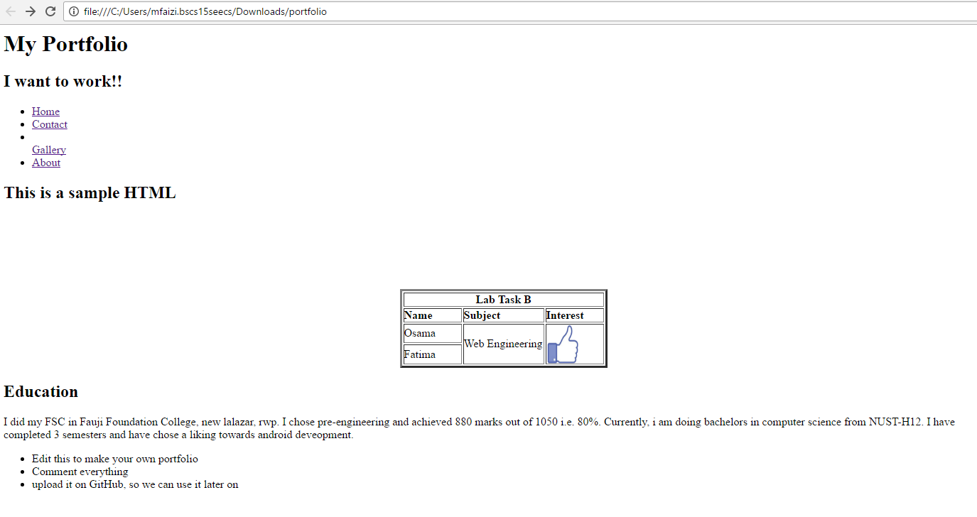

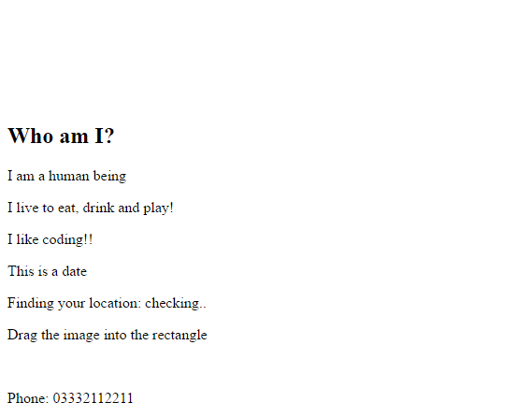

We have made 2 types of hyperlinks, one for forwarding towards the same page and second for forwarding towards a new page.

We have made a table using row and column span to make the required format.